GO GREEN TO SPACE

Global warming is a big concern for earth that scientist are trying to reduce it by developing in technology of different kinds of fields. One

of the concerns is increasing Rocket’s launch by developing at Space challenges, so to reduce this concerns we can use many method like Space Elevator but the problem is that this idea is a concept and we have a long way to reach this point.

The idea that can help us to improve Rocket’s propel to lift off it’s to use MAGLEV, which is widely using for Maglev trains in many countries. To develop this idea for Rockets we need a huge change in design of Launch Pad system that is described below, While Civil, Mechanical, and electrical engineers can involve with this Project.

To use maglev for Rockets instead of vertical Launch pad we need horizontal launch pad either, but we should gradually increase the degree of launch pad to prevent any error happens during launch.

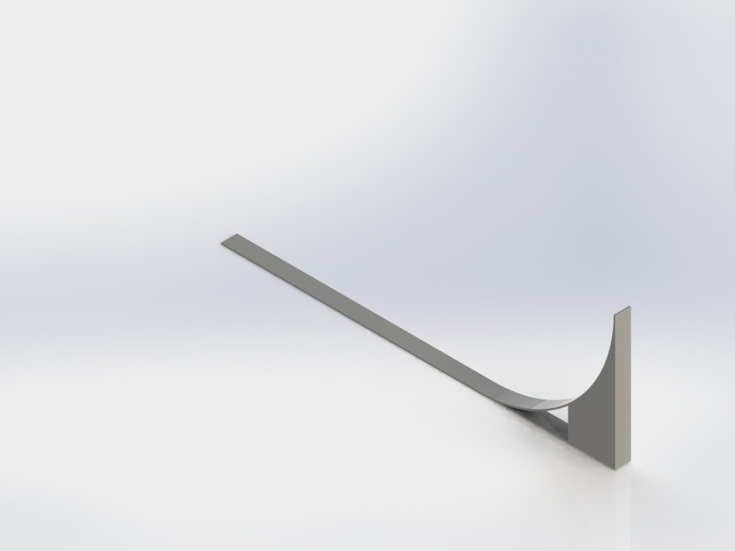

Fig 1.

Therefore, similarly we should use the same path way as we are using it for maglev train, however for rocket we need a parabola shape of rail’s way.

Principle:

When a conductive loop experiences a changing magnetic field, from [Lenz's law](http://en.wikipedia.org/wiki/Lenz%27s_law) and [Faraday's law](http://en.wikipedia.org/wiki/Faraday%27s_law_of_induction), the changing magnetic field generates an [Electromotive Force](http://en.wikipedia.org/wiki/Electromotive_Force) (EMF) around the circuit. Lenz’s law is a common way of understanding how electromagnetic circuits obey Newton’s third law and conservation of energy.



Where *N* is the number of turns of wire, and Φ*B* is the magnetic flux in webers through a *single* loop.

Since the field and potentials are out of phase, both attractive and repulsive forces are produced, and it might be expected that no net lift would be generated. However, although the EMF is at 90 degrees to the applied magnetic field, the loop inevitably has inductance. This inductive impedance tends to delay the peak current, by a phase angle dependent on the frequency since the [inductive impedance](http://en.wikipedia.org/wiki/Inductive_impedance) of any loop increases with frequency.



where **K** is impedance of the coil, **L** is the inductance and **R** is the resistance, the actual phase lead being derivable as the inverse tangent

of the product **ωL/R**, *viz.*, the standard phase lead evidence in a single-loop RL circuit, However



where **I** is the current.

Thus at low frequencies, the phases are largely orthogonal and the currents lower, and no significant lift is generated. But at sufficiently high frequency, the inductive impedance dominates and the current and the applied field are virtually in line, and this current generates a magnetic field that is opposed to the applied one, and this permits levitation.

However, since the inductive impedance increases proportionally with frequency, so does the EMF, so the current tends to a limit when the resistance is small relative to the inductive impedance. This also limits the lift force. Power used for levitation is therefore largely constant with frequency. However there are also eddy currents due to the finite size of conductors used in the coils, and these continue to grow with frequency. Figure 2 shows how the maglev system works.

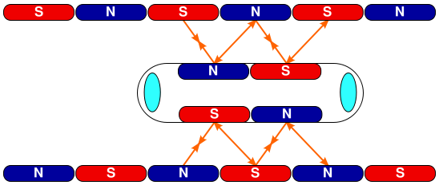

Fig2.

As long as we are dealing with a concept we can not exactly talk about the distance that the rocket should travel along the path way to get the enough acceleration for lift off; hence after leaving launch pad is the time for main ignition to accelerate more but the point can make this application and design specific is that we will use less fuel and apply less pressures on the rocket engines to lift off .

The magnetic body of the rocket after lift off and before leaving the atmosphere can easily and safe comes back to the earth by parachute to use it in next launch for other Rockets on the path way.

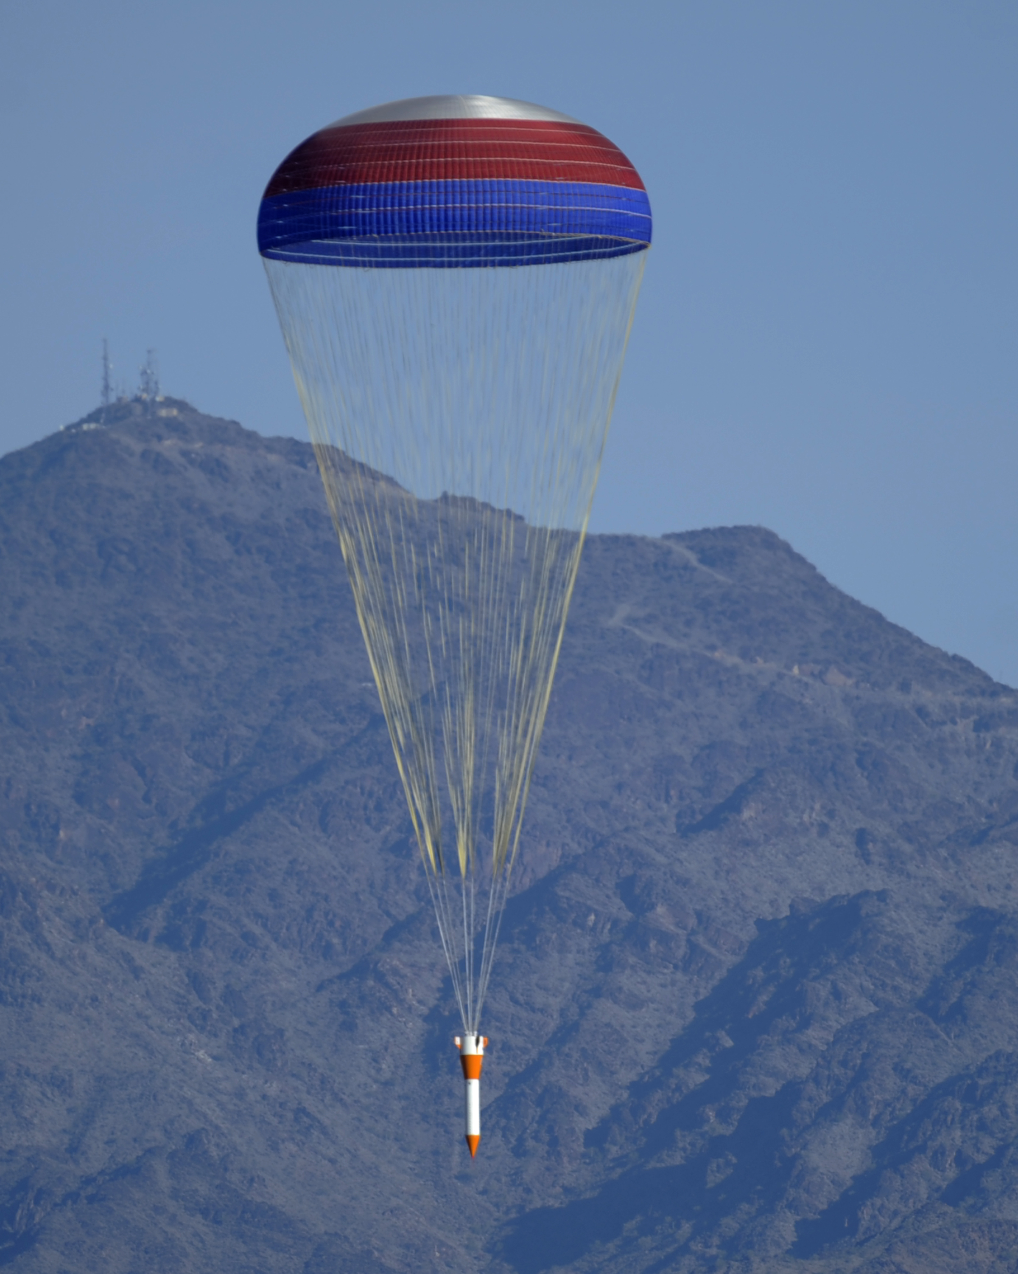

Fig 3.

In this kind of design for launch Pad, Rockets would have vibration source causing by rail way, therefore to reduce Vibrations and peak loads we required to use Mass damper and Vibration Isolators.

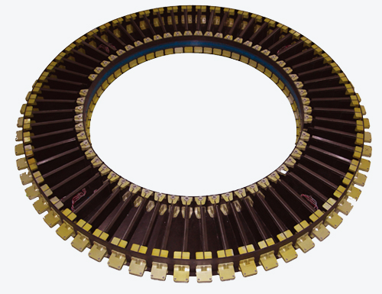

Fig 4.

One of the benefits of this launch pad is to reduce loads and size of rockets by accelerating them without using any fuel and simply we will be able to make the size of engines smaller because we may not required use them for lift off.

The Radial Moment of inertia measure how much the rocket is going to resist rolling, the greater the number the harder it will be to spin the rocket, but on the other than that increasing the radial moment of inertia in this way only makes the Rocket heavier and therefore reduce its performance. On the other hand reducing the radial moment of inertia makes it really easy to start a rocket spinning that it helps decrease dispersion of the rocket making it flight straighter.